ATS ENGINE — HIGH-LEVEL ARCHITECTURE DIAGRAM (Word-Optimised Version)
A tidy, structured, presentation-ready design
System Architecture Overview
The ATS Engine processes job descriptions through a structured pipeline:
- Input
- Metadata Extraction
- Scoring (Compare Rule + Dynamic Weighting)
- Routing
- CV Selection
- Automation
- Notes Generation
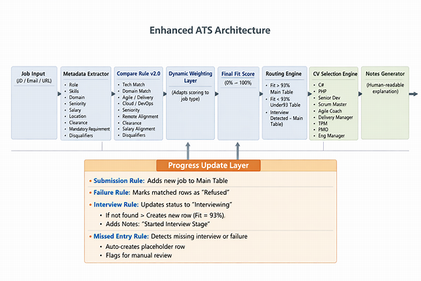

Explanation
The image is a map of how my ATS Engine thinks and acts when you paste a job description. It’s split into two layers:

The top layer — the main pipeline
This is the brain of the system. It shows how a job moves through each stage:
- Job Input — You paste a job description, email, or link.
- Metadata Extractor — The system reads the job and pulls out details like role, skills, location, salary, and clearance.
- Compare Rule v2.0 — It scores how well my profile matches the job, checking tech stack, domain, seniority, and other criteria.
- Dynamic Weighting Layer — Adjusts the scoring depending on the job type (e.g., Scrum Master vs Developer).
- Final Fit Score — Produces a percentage match from 0–100%.
- Routing Engine — Decides where the job goes:
  - High match (≥93%) → Main Table
  - Lower match → Under93 Table
  - Interview detected → Main Table
- CV Selection Engine — Chooses the best CV version for that role.
- Automation Engine — Handles all the follow-up work: cover letters, interview prep, status updates, duplicate checks.
- Notes Generator — Writes a clear summary explaining what happened and why.

The bottom layer — the rules layer
This is the autopilot that keeps everything tidy and accurate. It runs in parallel with the automation engine and handles real-world events:
- Submission Rule — Adds new jobs to the main tracking table.
- Failure Rule — Marks rejected or unsuccessful applications as “Refused.”
- Interview Rule — Updates the status to “Interviewing.”
  - If no record exists, it creates one automatically and sets Fit = 93%.
  - Adds a note saying “Started Interview Stage.”
- Missed Entry Rule — Detects missing interviews or failures.
  - Creates placeholder rows.
  - Flags them for manual review.

In short
The top half shows how the system evaluates and automates my applications. The bottom half shows how it keeps my data clean and complete — fixing gaps, logging interviews, and marking outcomes automatically.
Together, they form a self-maintaining, intelligent ATS engine that scores, routes, and updates everything without manual effort.

